**PREET TAILOR OOP2 BBT 2101**

# **LAB 3**

# **JAVA AND DATABASE CONNECTIVITY**

………………………………………………………………………………………………………………………………………………………………….

# Section 1

Start MySQL database in your machine and use PHPMyAdmin to run a query.

1. Your database name should be *ics2101*
2. Which creates a table,*student_details*, with the following fields:

|  |  |  |
| --- | --- | --- |
| **Field name** | **Data type** | **Description** |
| student_id | Integer | Is the primary of the relation, should not be AUTO_INCREMENT. A user MUST provide value for it |
| first_name | Character varying | First name of the student |
| last_name | Character varying | Last name of the student |
| gender | Integer | Gender of student. Thisfield only accepts 0 or 1, 0 for female and 1 for male. However, a user inputs it as male and female so that you java program converts it to a 1 or a 0 |
| degree_programme | Text | The name of the degree programmer a student is taking at university |

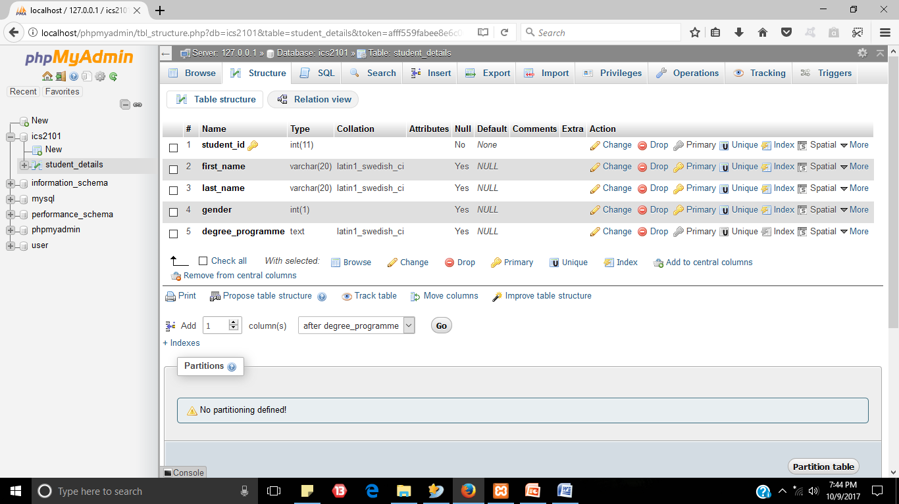

1. Proceed by creating a java class, *DBConnector*, that will create a connection and close a connection to the above database.

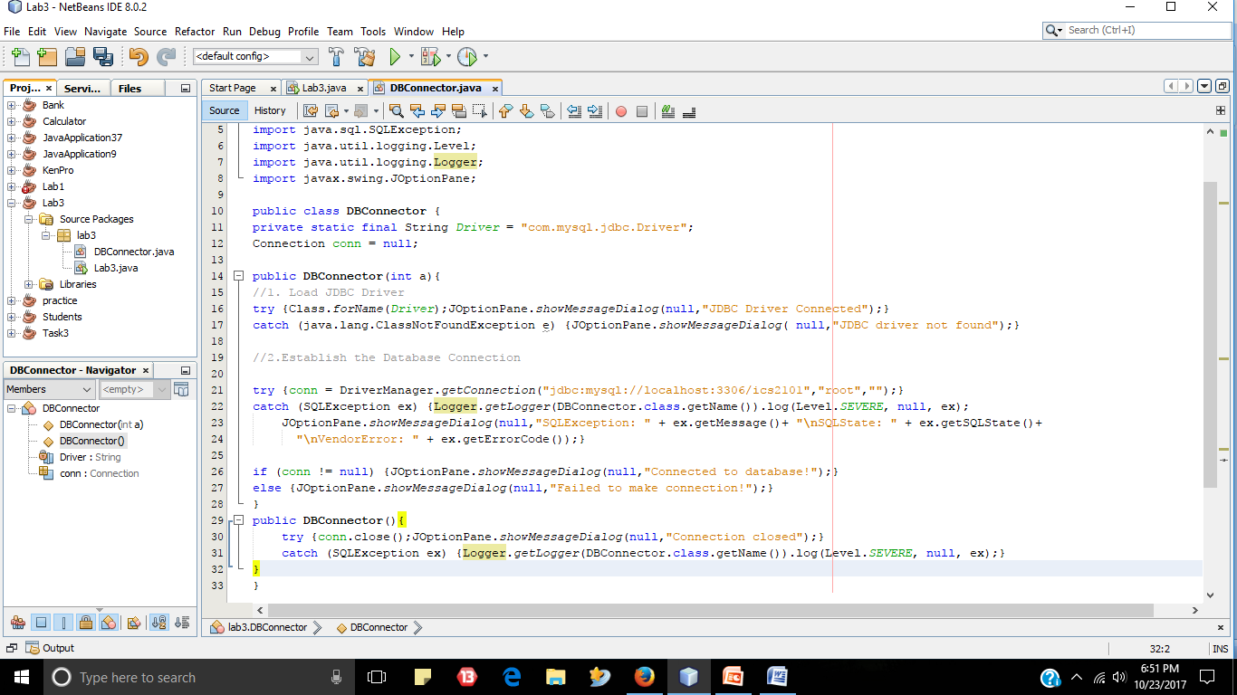

1. Do not forget to add the JDBC driver as a library to your application – download it here <https://dev.mysql.com/downloads/connector/j/>

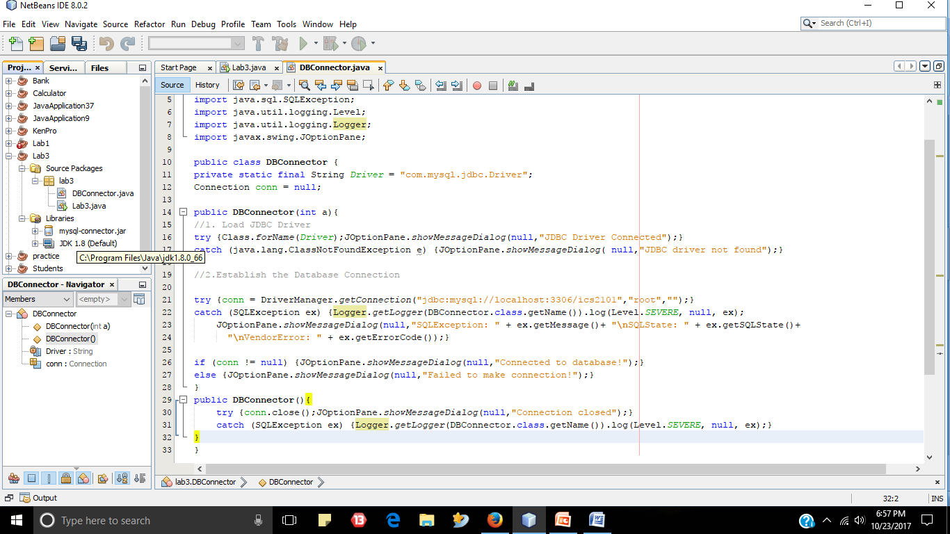

1. Create a simple menu as shown below to be used by a user to perform the operations shown below (use a switch…case control structure in your java code). If Java’s switch…case structure does not support characters, you can use integers instead.

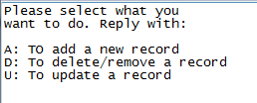

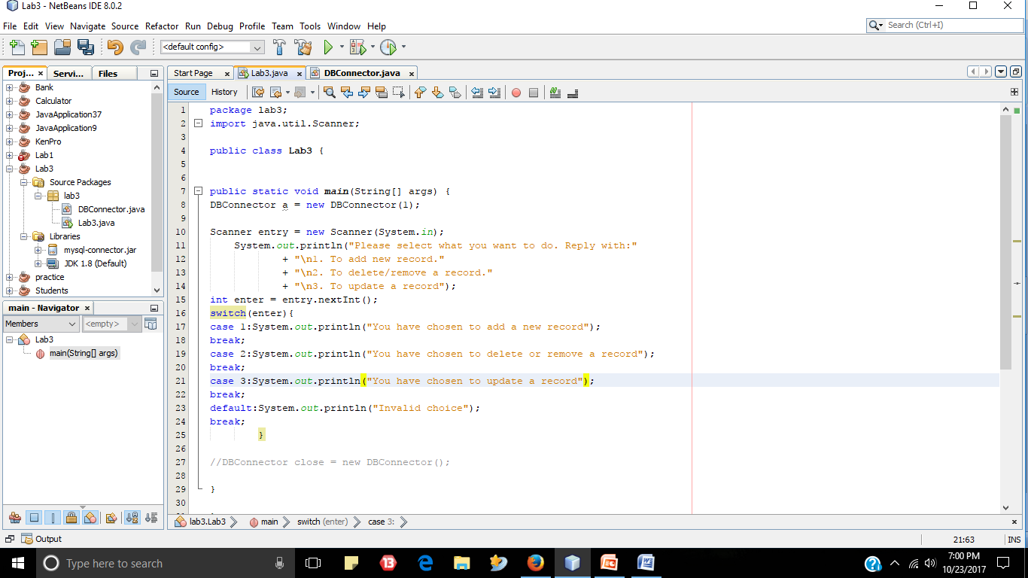

The options are summarized in the table below

|  |  |
| --- | --- |
| **Option** | **Description** |
| A | When selected, then a user wants to add a record. Note that a user can add one record or multiple record. Thus a do …while loop maybe used to loop should a user want to add multiple record. When adding multiple records, use a batch to execute all the insert queries at ones. You MAYalso want to use java HashMap and List – refer to java documentation (<https://docs.oracle.com/javase/8/docs/api/java/util/HashMap.html> and <https://docs.oracle.com/javase/8/docs/api/java/util/List.html> ) |
| D | When selected, then a user wants to remove a record. Thus, you will allow a user to specify a student_id of the record to be deleted. If such record specified is not found, it should be reported. |
| U | When selected, then a user wants to edit some record, which they have to specify using student_id. |

**N/B:You MUST use prepared statements to execute your queries.**

The operations discussed in table above should be implemented in a class, Crud, as methods.

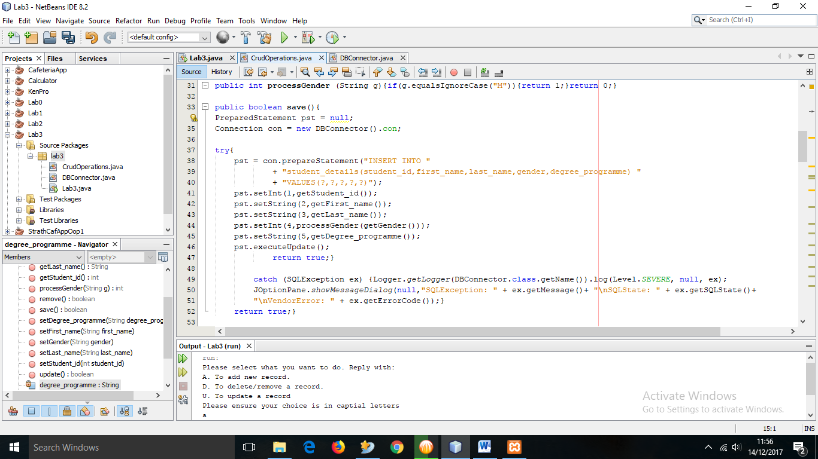

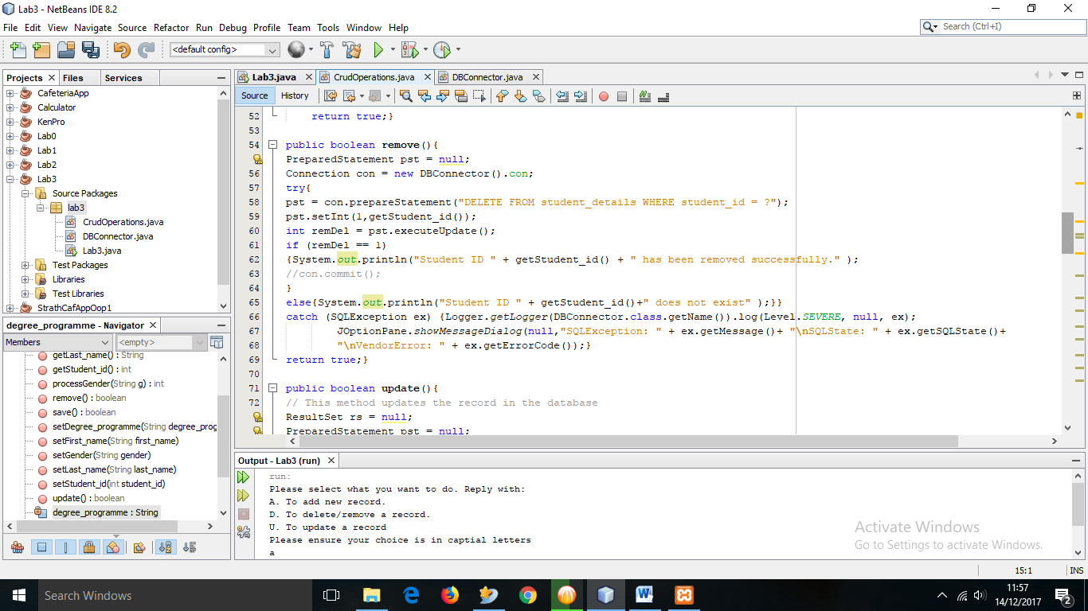

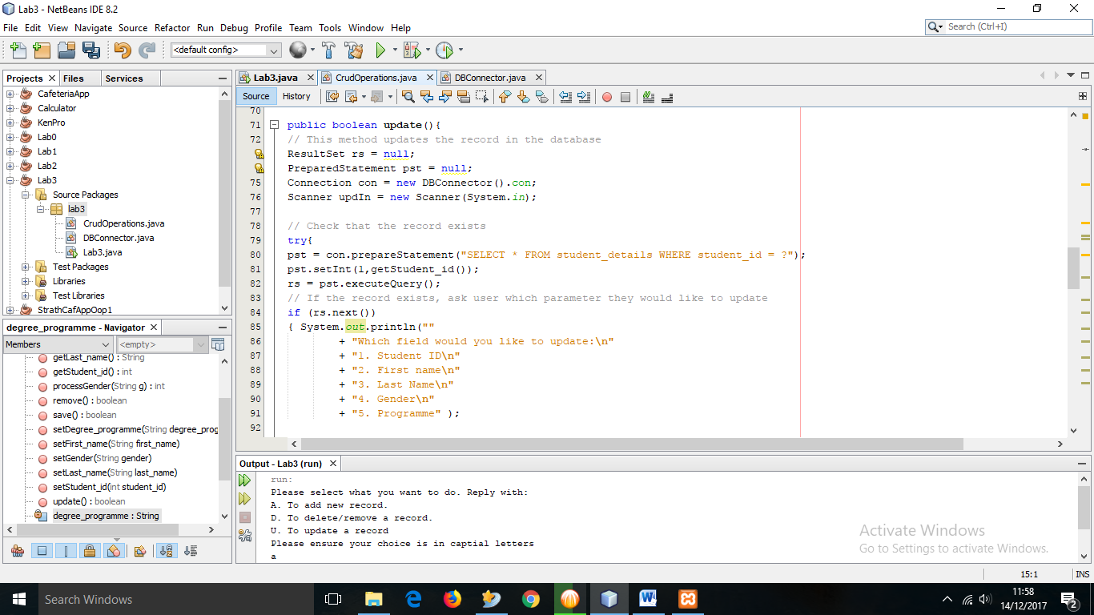

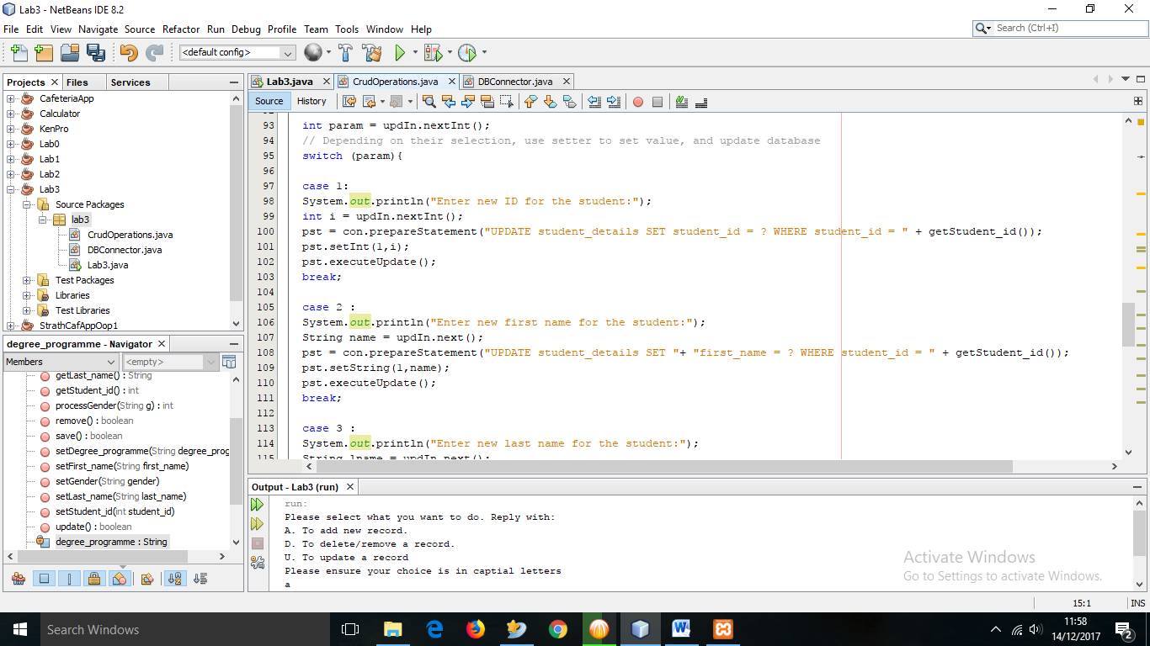

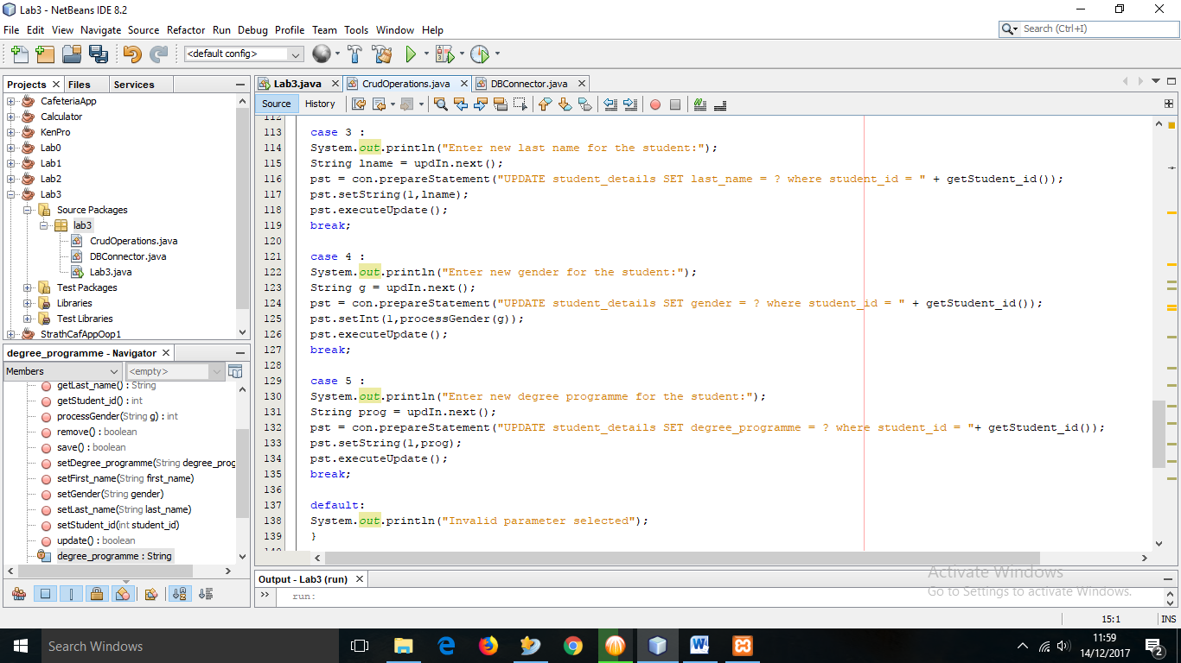

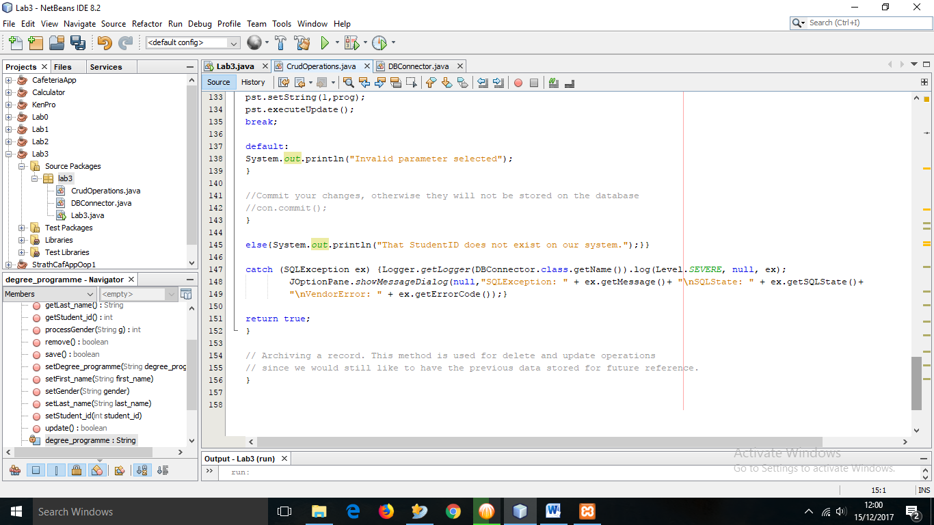

# Section II

In the same MySQL database, create another table, *student_old*

|  |  |  |
| --- | --- | --- |
| **Field name** | **Data type** | **Description** |
| Id | Integer | AUTO_INCREMENT, primary key of the table |
| student_id | Integer | Is the primary of the relation, should not be AUTO_INCREMENT. A user MUST provide value for it. This column is a foreign key from table *student_details* |
| first_name | Character varying | First name of the student |
| last_name | Character varying | Last name of the student |
| gender | Integer | Gender of student. This field only accepts 0 or 1, 0 for female and 1 for male. However, a user inputs it as male and female so that you java program converts it to a 1 or a 0 |
| degree_programme | Text | The name of the degree programmer a student is taking at university |

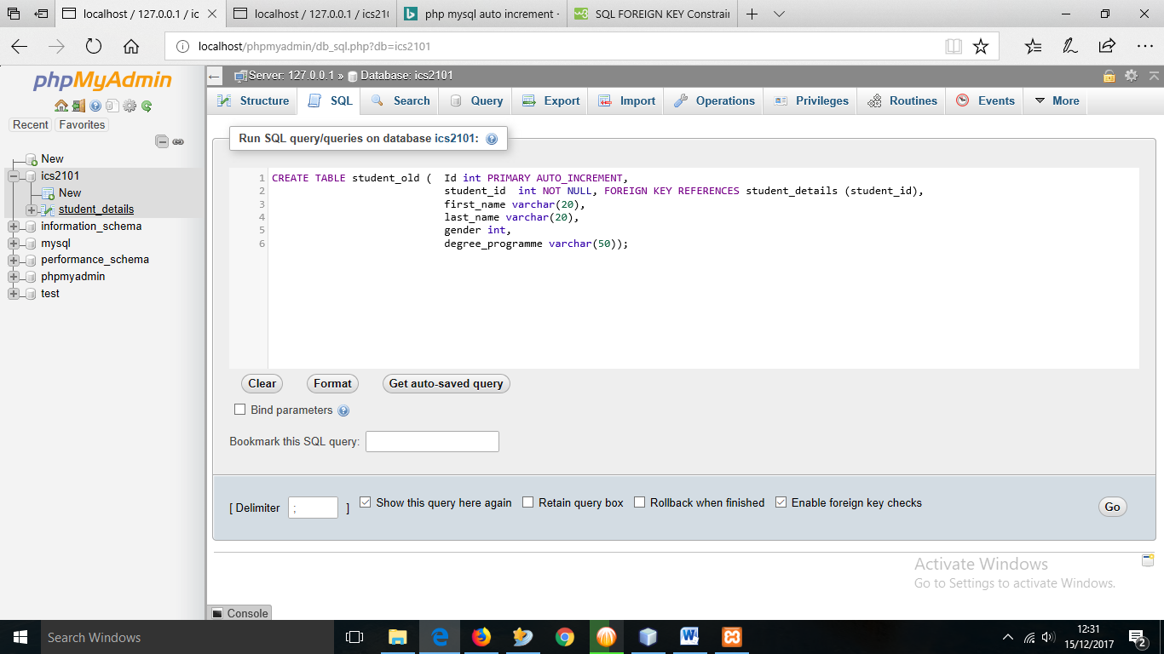

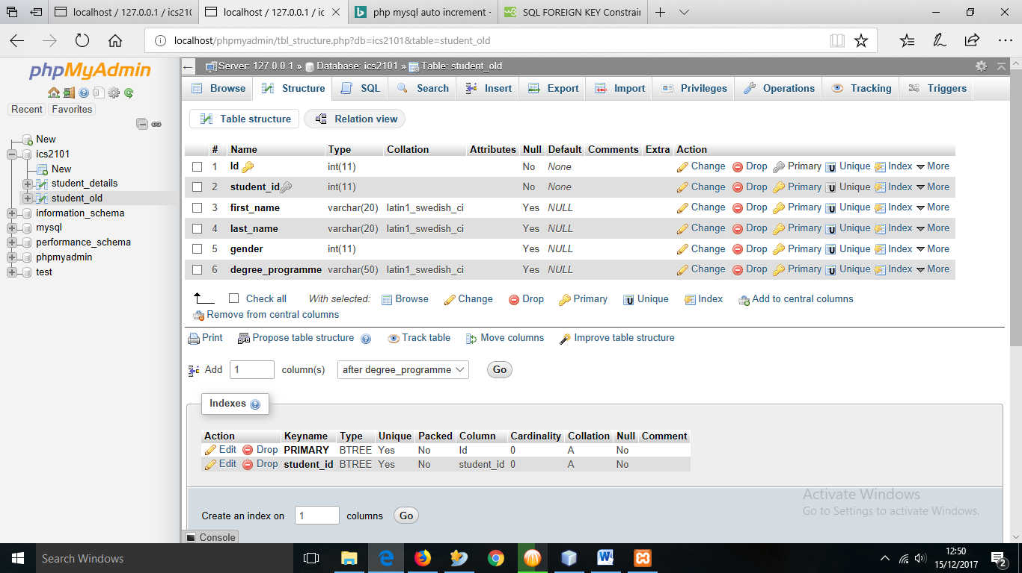

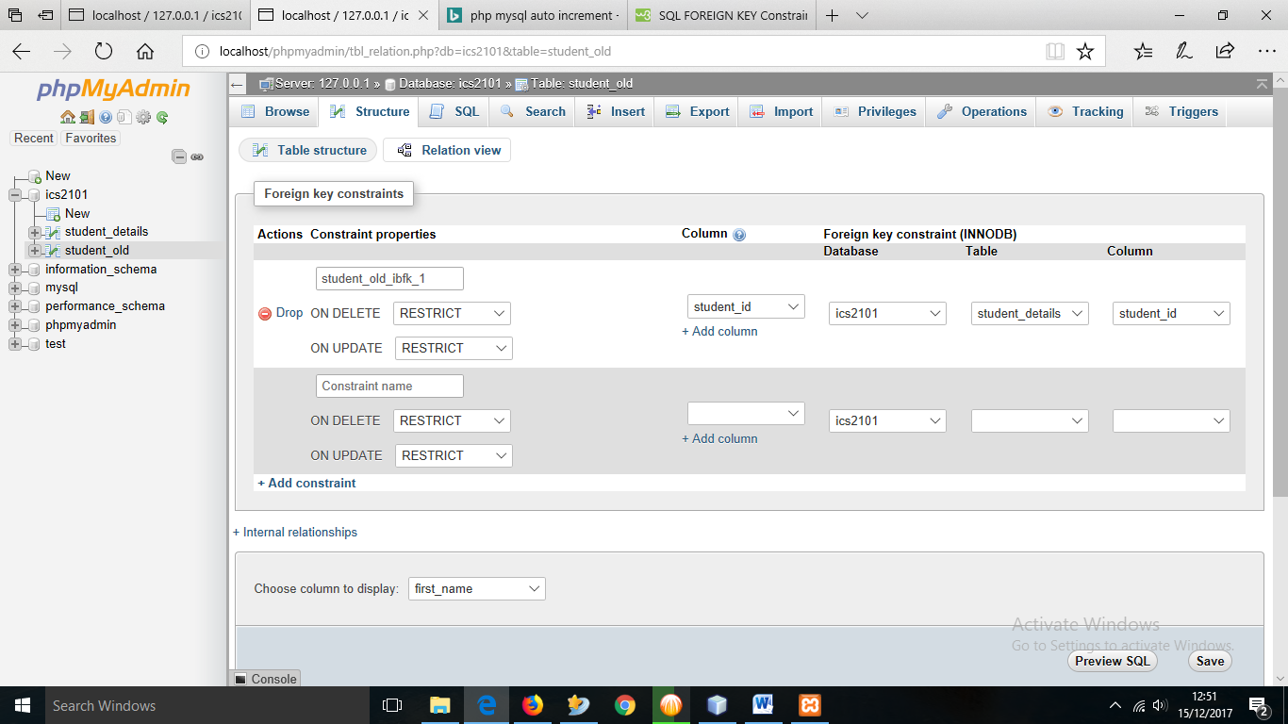

When a user tries to update a record in *student_details* table, the old record is inserted in table *student_old,* before making the update. Implement these two insertions as a TRANSACTION. Should there be a problem with one insertion, then, you need to rollback. Otherwise, commit.

1. Set auto commit to false

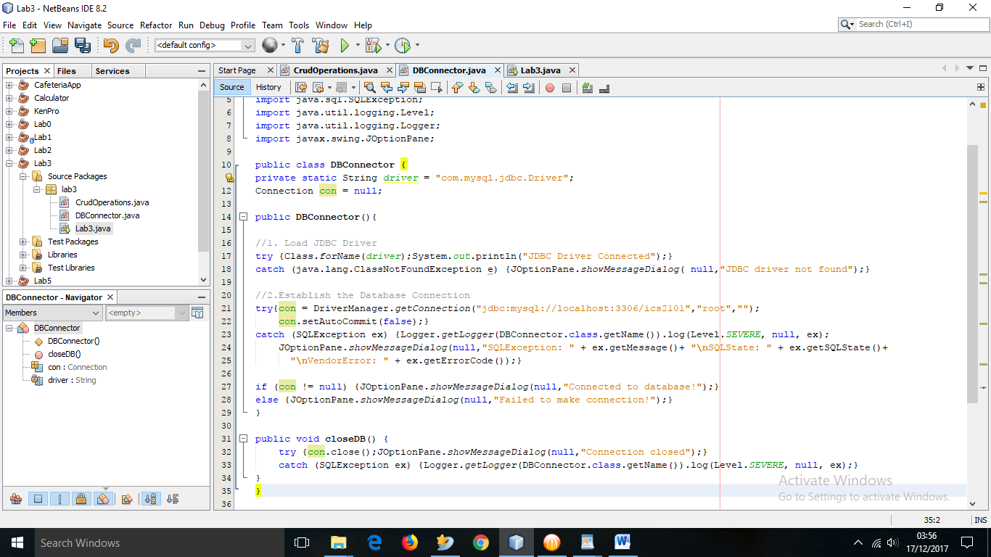

1. Con.commit for save

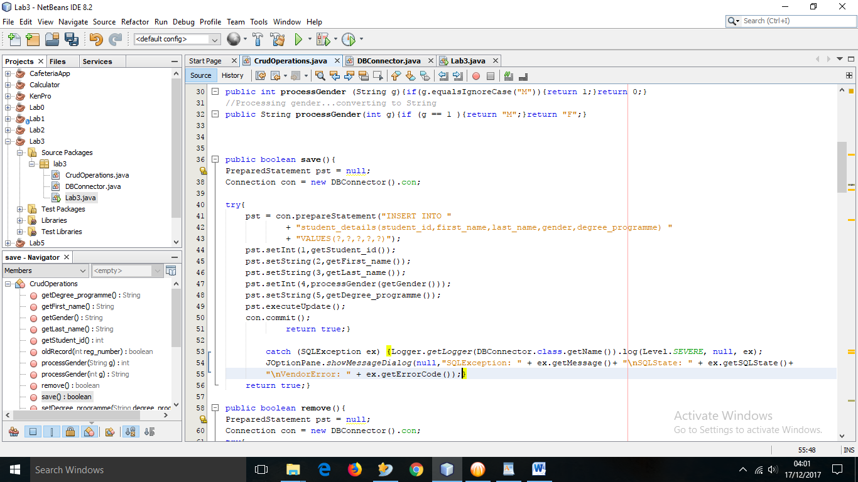

1. Save record in old table when updating and deleting

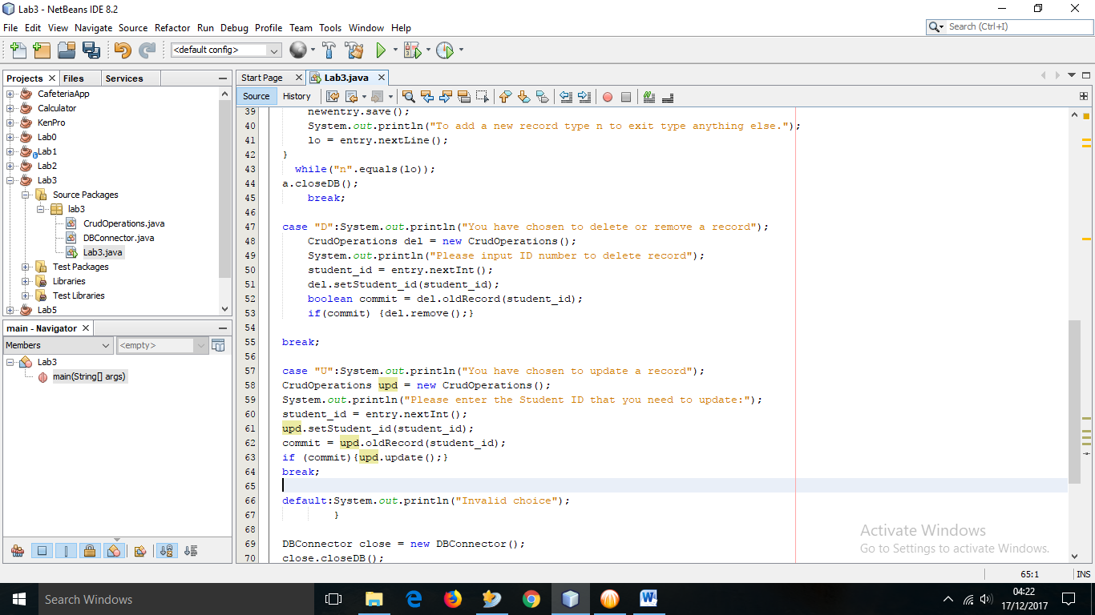

**-This lab is complete-**